**Project Planning Phase**

**Project Planning (Product Backlog, Sprint Planning, Stories, Story points)**

|  |  |
| --- | --- |
| **Date** | 29 October 2022 |
| **Team ID** | PNT2022TMID22731 |
| **Project Name** | Project – Web Phishing Detection |
| **Maximum Marks** | 8 Marks |

**Product Backlog, Sprint Schedule and Estimation (4 Marks)**

**Product backlog and sprint schedule:**

|  |  |  |  |  |  |  |
| --- | --- | --- | --- | --- | --- | --- |
| **Sprint** | **Functional**  **Requirement (Epic)** | **User**  **Story**  **Number** | **User Story / Task** | **Story Points** | **Priority** | **Team Members** |
| Sprint-1 | Homepage | USN-1 | As a user, I can explore the resources of the homepage for the functioning | 10 | Low | SONIYA.D, RIYA K MATHEW,  NIVEDHA.E , SRIVARSHAN |
| Sprint-1 | Url detection | USN-2 | As a user, I can learn about the various sides of the web phishing and be aware of the scams | 5 | High | SONIYA.D, RIYA K MATHEW,  SRIVARSHAN |
| Sprint-2 | Final page | USN-3 | As a user, I can explore the resources of the final page for the functioning | 15 | Low | SONIYA.D, RIYA K MATHEW,  NIVEDHA.E |
| Sprint-3 | Prediction | USN-4 | As a user, I can predict the URL easily for  detecting whether the website is  legitimate or not | 10 | High | SONIYA.D, RIYA K MATHEW,  NIVEDHA. E , SRIVARSHAN |
| Sprint-4 | Chat | USN-5 | As a user, I can share the experience or contact the admin for the support | 10 | High | SONIYA.D, RIYA K MATHEW,  NIVEDHA.E , SRIVARSHAN |
| Sprint-1 | Homepage | USN-6 | As a admin, we can design interface and maintain the functioning of the website | 5 | High | SONIYA.D, RIYA K MATHEW,  NIVEDHA.E , SRIVARSHAN |
| Sprint-2 | Final page | USN-7 | As a admin, we can design the complexity of the website for making it user-friendly | 5 | Medium | SONIYA.D,  NIVEDHA.E , SRIVARSHAN |
| Sprint-3 | Prediction | USN-8 | As a admin, we can use various ML classifier model for the accurate result for the detection of URL | 10 | High | SONIYA.D, RIYA K MATHEW,  NIVEDHA.E , SRIVARSHAN |
| Sprint-4 | The final step | USN-9 | As a admin, we can response to the user message for improvement of the website | 10 | Medium | SONIYA.D, RIYA K MATHEW,  NIVEDHA.E , SRIVARSHAN |

**Project Tracker, Velocity & Burndown Chart (4 Marks)**

|  |  |  |  |  |  |  |
| --- | --- | --- | --- | --- | --- | --- |
| **Sprint** | **Total Story Points** | **Duration** | **Sprint Start Date** | **Sprint End Date (Planned)** | **Story Points**  **Completed (as on**  **Planned End Date)** | **Sprint Release Date (Actual)** |
| Sprint-1 | 20 | 6 Days | 24 Oct 2022 | 29 Oct 2022 | 20 | 29 Oct 2022 |
| Sprint-2 | 20 | 6 Days | 31 Oct 2022 | 05 Nov 2022 | 20 | 05 Nov 2022 |
| Sprint-3 | 20 | 6 Days | 07 Nov 2022 | 12 Nov 2022 | 20 | 12 Nov 2022 |
| Sprint-4 | 20 | 6 Days | 14 Nov 2022 | 19 Nov 2022 | 20 | 12 Nov 2022 |

**Velocity:**

Imagine we have a 10-day sprint duration, and the velocity of the team is 20 (points per sprint). Let’s calculate the team’s average velocity (AV) per iteration unit (story points per day)

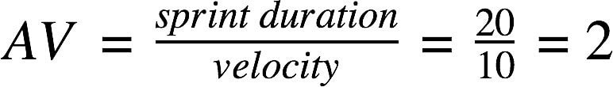

We have a 6-day sprint duration, and the velocity of the team is 20 (points per sprint). So our team’s average velocity (AV) per iteration unit (story points per day)

# AV = (Sprint Duration / Velocity) = 20 /6 = 3.33

**Burndown Chart:**

A burn down chart is a graphical representation of work left to do versus time. It is often used in agile software development methodologies such as Scrum. However, burn down charts can be applied to any project containing measurable progress over time.

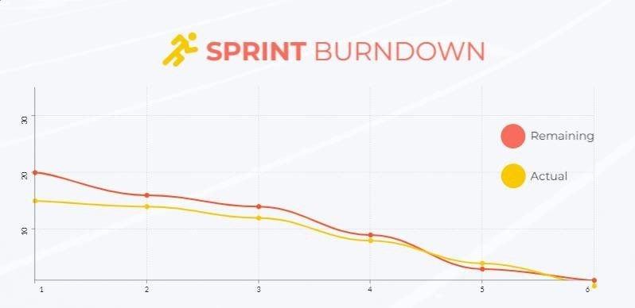

**Reference:**

**https://www.visual-paradigm.com/scrum/scrum-burndown-chart/**

**https://www.visme.co/templates/charts/sprint-burndown-chart-1425285230/**

**Reference:** [**https://www.atlassian.com/agile/project-management**](https://www.atlassian.com/agile/project-management) [**https://www.atlassian.com/agile/tutorials/how-to-do-scrum-with-jira-software**](https://www.atlassian.com/agile/tutorials/how-to-do-scrum-with-jira-software) [**https://www.atlassian.com/agile/tutorials/epics**](https://www.atlassian.com/agile/tutorials/epics) [**https://www.atlassian.com/agile/tutorials/sprints**](https://www.atlassian.com/agile/tutorials/sprints) [**https://www.atlassian.com/agile/project-management/estimation**](https://www.atlassian.com/agile/project-management/estimation) [**https://www.atlassian.com/agile/tutorials/burndown-charts**](https://www.atlassian.com/agile/tutorials/burndown-charts)